- CodeHousie offered a distinctive and innovative format by seamlessly integrating coding challenges with the traditional Housie game, creating an intellectually stimulating yet engaging competitive environment. The contest was held in the computer laboratories on the fourth floor on Thursday, 16th October 2025.

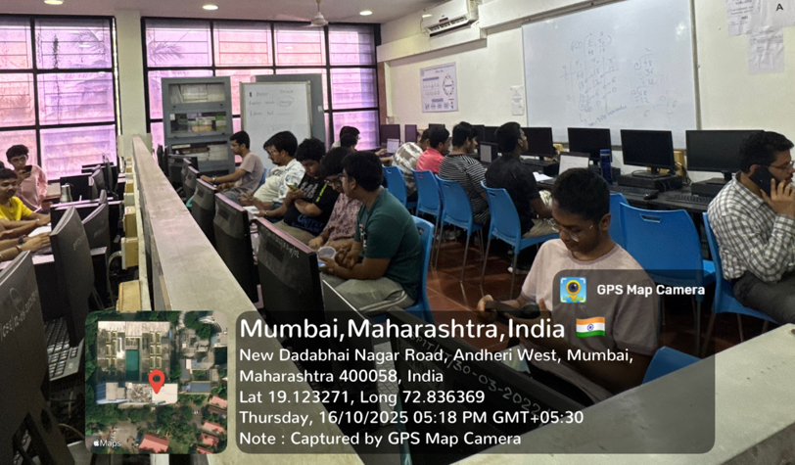

Fig Students actively solving problems in CodeHousie

2 Pixel Perfect

C.S.I.- SPIT, in collaboration with ACSES SPIT, successfully organized Pixel Perfect, a frontend-focused hackathon aimed at enhancing practical UI/UX and frontend development skills among undergraduate engineering students. The event was conducted on 14th February 2026 at Sardar Patel Institute of Technology (SPIT) and witnessed enthusiastic participation from 211 students across multiple colleges and specializations.
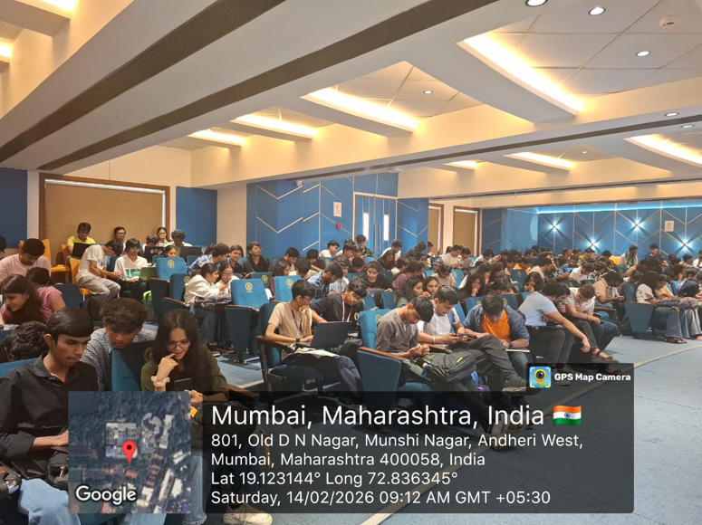

Fig . Initial briefing of rules to all participants

3. SPIT Hackathon

SPIT Hackathon was a national-level 24-hour hackathon conducted on 21st and 22nd February 2026, bringing together some of the brightest student innovators, developers, and problem-solvers from across the country. The event witnessed an overwhelming participation of 3,316 students, reflecting both the growing interest in hackathons and the competitive spirit among participants. After a rigorous selection process, 78 teams were shortlisted for the final round, with each team comprising 2- 4 members to encourage collaborative ideation and effective execution.
The competition was structured into four major tracks - Artificial Intelligence & Machine Learning (AIML), Web Development, App Development, and Blockchain- with each track offering two carefully curated problem statements, resulting in a total of eight practical and industry-relevant challenges.

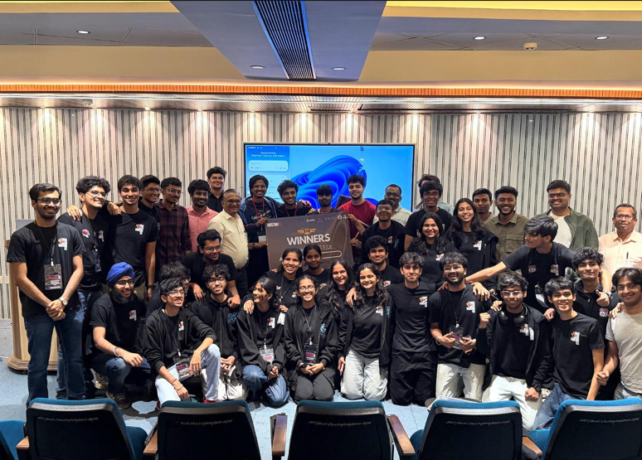

Fig . Closing ceremony

